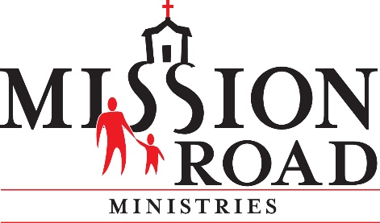
May 1, 2020

Dear Mission Road Family:

We are proud to have one focus and one priority at Mission Road –
keeping our residents, clients and employees healthy, engaged and safe.

In order to reduce the risk of exposure, to the Coronavirus, we announced the closure of our campus and community homes to visitors on March 16, 2020.

The city of San Antonio and Bexar County’s Stay Home Work Safe Measures have been extended. The city of San Antonio’s COVID-19 Health Transition Team has created a four-phase plan for the re-opening of the city. Currently, due to evidence of continued community spread of COVID-19 infections, we remain in Phase 1 (Stay Home Work Safe) In order to move out of Phase 1, the data for the city of San Antonio must show that the transmission of COVID-19 has slowed or been reduced.

People living in congregate settings and community homes are at an increased risk for infection because social distancing is difficult to maintain. In addition, the number of people in one setting at the same time raises the risk of infection. The Governor’s Report to Open Texas hi-lights the rapid increase of COVID-19 in long-term care facilities and urges a strong and consistent response in preventing the infection in those facilities.

Day Activity Programs
With all that said, we have decided, for the safety of everyone, to continue the closure of our campus and community homes through May 31, 2020. This includes our Free To Be Day Activity Program at Mission Road Developmental Center and our Day Activity Program and Job & Life Skills Training Program at Unicorn Centers.

S.O.A.R. Summer Camp for Children
Our KOALA summer day camp program for community kids will be closed this summer.
To all our KOALA campers, we are working on a virtual camp that you can attend from home. Norma Gaitan and her team are eagerly working on a daily curriculum of fun, meaningful and engaging activities. We will be getting in touch with you regarding the details.

We hope that we can reopen our adult day activity programs, and reopen the campus and community homes to visitors, by June 1, 2020. However, so much will depend on where
Texas and the nation are regarding the containment of the virus.

Residential Program and Community Homes
Our community homes remain closed to all visitors through May 31, 2020. All face-to-face visits will need to be rescheduled or other options chosen to stay in contact, such as, video chat, emails and phone calls. The City’s Stay Home Work Safe order does not permit visitors to any long-term care facilities – including our Mission Road Community Homes. Only employees and those providing critical assistance as determined through the guidance from the Texas Health and Human Services Commission are allowed entry. Please feel free to reach out to the resident’s program/case manager for information as well.

If you wish to take a resident out of the home for a visit, we ask that you keep them with you for 14 days, before returning them to the home. They also must be asymptomatic (free from fever and cough). The more interactions and contacts an individual has the higher the risk for spreading COVID-19. The importance of keeping our residents and employees healthy is our main priority.

Please visit us here in late May for more updates.

Stay safe and well,

Lora Butler, President, COO

